P 2 Multi-Area OSPF with Stub Areas and Authentication
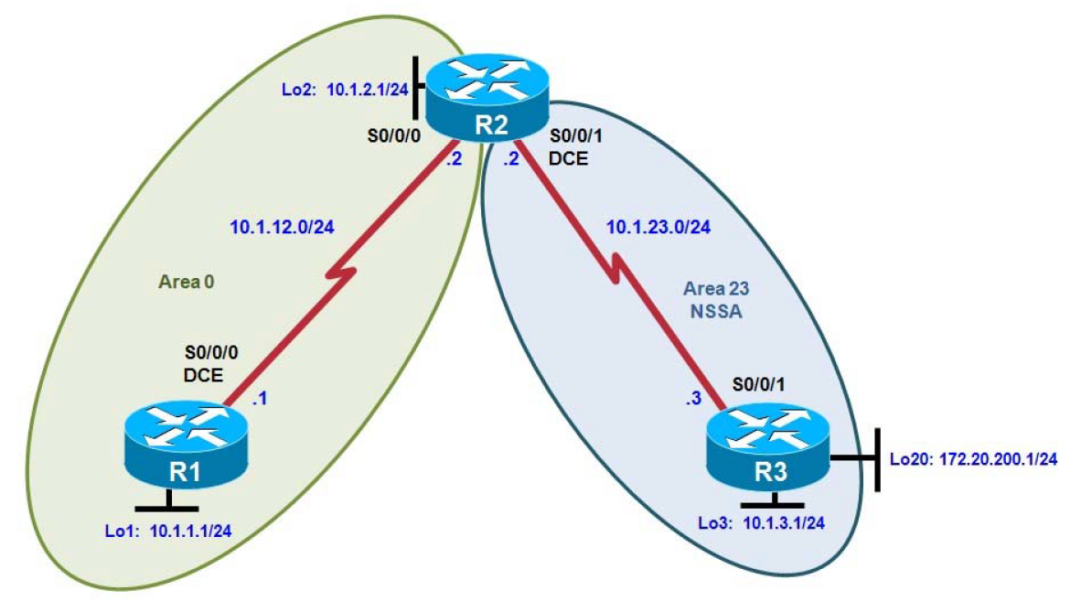

Background:
You are responsible for configuring the new network to connect your company’s engineering, marketing, and accounting departments, represented by loopback interfaces on each of the three routers. The physical devices have just been installed and connected by serial cables. Configure multiple-area OSPF to allow full connectivity between all departments.

Objectives
• Configure multiple-area OSPF on a router.
• Verify multiple-area behavior.
• Configure OSPF stub, totally stubby, and not-so-stubby areas.
• Configure OSPF authentication.

Step 1: Configure addressing and loopbacks.

R1# configure terminal
Enter configuration commands, one per line. End with CNTL/Z.
R1(config)# interface loopback 1
R1(config-if)# description Engineering Department
R1(config-if)# ip address 10.1.1.1 255.255.255.0
R1(config-if)# interface serial 0/0/0
R1(config-if)# ip address 10.1.12.1 255.255.255.0
R1(config-if)# clockrate 64000
R1(config-if)# no shutdown

R2# configure terminal
Enter configuration commands, one per line. End with CNTL/Z.
R2(config)# interface loopback 2
R2(config-if)# description Marketing Department
R2(config-if)# ip address 10.1.2.1 255.255.255.0
R2(config-if)# interface serial 0/0/0
R2(config-if)# ip address 10.1.12.2 255.255.255.0
R2(config-if)# no shutdown
R2(config-if)# interface serial 0/0/1
R2(config-if)# ip address 10.1.23.2 255.255.255.0
R2(config-if)# clockrate 64000
R2(config-if)# no shutdown

R3# configure terminal
Enter configuration commands, one per line. End with CNTL/Z.
R3(config)# interface loopback 3
R3(config-if)# description Accounting Department
R3(config-if)# ip address 10.1.3.1 255.255.255.0
R3(config-if)# interface loopback 20
R3(config-if)# description Connection to another AS
R3(config-if)# ip address 172.20.200.1 255.255.255.0
R3(config-if)# interface serial 0/0/1
R3(config-if)# ip address 10.1.23.3 255.255.255.0
R3(config-if)# no shutdown

Step 2: Add interfaces into OSPF.

R1(config)# router ospf 1
R1(config-router)# network 10.1.12.0 0.0.0.255 area 0
R1(config-router)# network 10.1.1.0 0.0.0.255 area 0
R1(config-router)# exit
R1(config)# interface loopback 1
R1(config-if)# ip ospf network point-to-point

R2(config)# router ospf 1
R2(config-router)# network 10.1.12.0 0.0.0.255 area 0
R2(config-router)# network 10.1.2.0 0.0.0.255 area 0
R2(config-router)# exit
R2(config)# interface loopback 2
R2(config-if)# ip ospf network point-to-point

Add the subnet between R2 and R3 into OSPF area 23 using the network command. Add loopback 3 on
R3 into area 23.

R2(config)# router ospf 1
R2(config-router)# network 10.1.23.0 0.0.0.255 area 23

R3(config)# router ospf 1
R3(config-router)# network 10.1.23.0 0.0.0.255 area 23
R3(config-router)# network 10.1.3.0 0.0.0.255 area 23
R3(config-router)# exit
R3(config)# interface loopback 3
R3(config-if)# ip ospf network point-to-point

Step 3: Configure a stub area.

R2(config)# router ospf 1
R2(config-router)# area 23 stub

R3(config)# router ospf 1
R3(config-router)# area 23 stub

Step 4: Configure a totally stubby area.

R2(config)# router ospf 1
R2(config-router)# area 23 stub no-summary

Step 5: Configure OSPF interface authentication.

R2(config)# interface serial 0/0/1
R2(config-if)# ip ospf authentication
R2(config-if)# ip ospf authentication-key cisco

R3(config)# interface serial 0/0/1
R3(config-if)# ip ospf authentication
R3(config-if)# ip ospf authentication-key cisco

R1(config)# interface serial 0/0/0
R1(config-if)# ip ospf authentication message-digest
R1(config-if)# ip ospf message-digest-key 1 md5 cisco

R2(config)# interface serial 0/0/0
R2(config-if)# ip ospf authentication message-digest
R2(config-if)# ip ospf message-digest-key 1 md5 cisco

